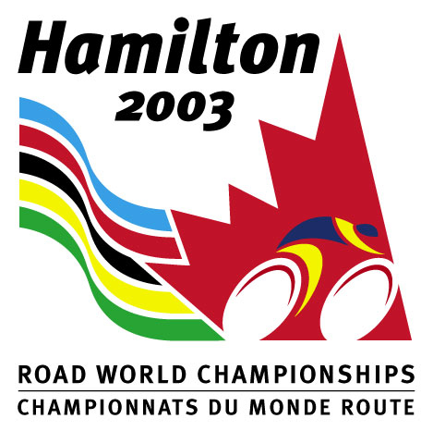 | HAMILTON ROAD FOUNDATION  Ross Chafe Award 2019

The Hamilton 2003 Road Cycling Foundation was established to support long term development of young road athletes from junior ranks to road professional teams and to support national talent identification of young road athletes.
Ross Chafe was a long serving member of the Hamilton Road Foundation Board and instrumental in obtaining positive investment returns for the Foundation’s funds. It was his philosophy that the Foundation should utilize its resources to the full extent possible to support developing riders. Ross and another Whistler Cycling Club rider were killed while riding northwest of Whistler in June of 2015. The Ross Chafe Award has been established to honour the memory of this significant contributor to the development of Canadian road cyclists.
Criteria for Award
The Award will be granted annually with both a female and male recipient receiving $ 5,000.00 based on the following criteria to be met by each applicant:
1. shall be a Top-8 finisher in the Road Race or Time Trial at the 2019 Canadian Road Championships in the Junior category,
2. shall not be a carded athlete,
3. has not received the award in previous years, and
4. shall have high academic standing in the school year completed in 2018-2019
5. shall provide his/her best performance in a National or International Race, for example in the Tour of Abitibi (men) or in the Tour de l’Avenir Makadence (Wn) in Quebec.
Application Process
Interested applicants should complete the attached Application Form and attach a photocopy of their 2018-19 school year final marks and forward it to the National Office by August 31, 2019. The Award will be made by November 1, 2019, towards the training and tuition costs of the recipients.
Send Application to: Hamilton Road Foundation
c/o Cycling Canada Cyclisme
203 – 2197 Riverside Drive
Ottawa, ON K1H 7X3
Email: general@cyclingcanada.ca
Fax: 613-248-9311
Ross Chafe Award 2019
Applicant’s Name: _______________________________________________________
Address: ________________________________________________________
________________________________________________________
Telephone No: _______________________ Email: __________________________
Results 2019 Canadian Junior Road Championships
Road Race _________________________________________________________
Time Trial _________________________________________________________
Other performance ______________________________________________________
Club: ________________________________ Coach’s Name: ________________________
High School /College / CEGEP / University: ____________________________________________
Major Program of Study: ___________________________________________________
Academic Goals: ____________________________________________________
Cycling Goals: ____________________________________________________
____________________________________________________
Comments by Coach or Teacher / Professor:
_____________________________________________________
_____________________________________________________
__________________________________ __________________________________

Applicant’s Signature Coach or Teacher / Professor’s Signature
By signing this application form, Applicant states that he/she understands, acknowledges and agrees that the determination of which applicant should be awarded the Ross Chafe award is to be made by the Hamilton Road Foundation’s board of directors in its sole discretion and that such decision shall not be subject to review or challenge in any forum.
RETURN TO THE CYCLING CANADA NATIONAL OFFICE BY August 31, 2019

